Timings/ settings for metalogics, (the proof of concepts for Sempra)
Conversion Approach
File share Conversion to SharePoint Online can be performed using the following 3 approaches

CSOM [Client-Side Object Model]
Using CSOM data is Converted as follows:
- Data from file shares are read using Metalogix adapters
- This data is uploaded to SharePoint Online one-by one using Client-side object model

Pros:
- Faster in comparison with Azure pipeline approach for small content [number of files <200 and file size <500MB]
- Conversion of files with size greater than 1.99 GB can be performed using CSOM

Cons:
- User to get throttled in SharePoint Online while moving large sites as multiple calls are initiated from single user to SPO
- Performance is slower in comparison with Azure Pipeline approach when large number of files are being Converted [>200 files]

Azure Pipeline

Using Azure Pipeline approach data is Converted as follows:
- Create the site/library in SharePoint Online using CSOM
- Create manifest package
- Upload manifest package to Azure blob storage (public storage by default/private storage)
- Timer job to import data to SharePoint Online and messages are written to queue

Pros:
- No user impact – as most of the activities occur in the backend of cloud infrastructure, a user of SharePoint Online will not face any impact from Conversion
- No user throttling by SharePoint Online

Cons:
- Performance is slower in comparison with CSOM with small number of files [<200 files]
- Files above 1.99 GB cannot be Converted using this approach

Drive Shipping
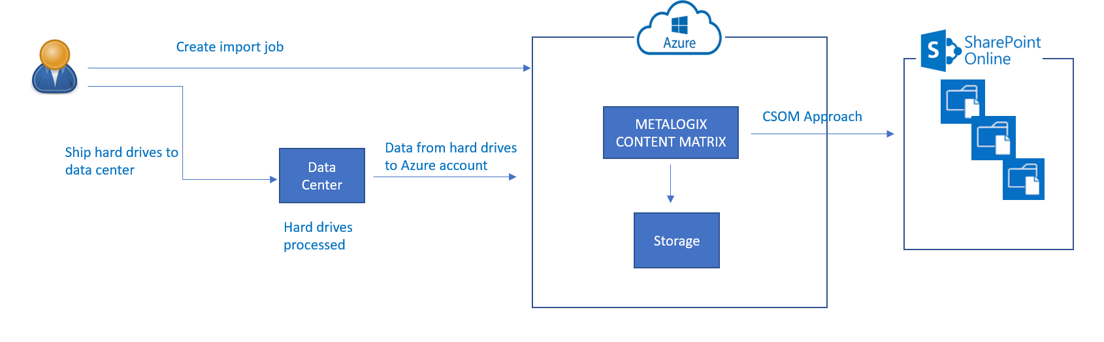

Using Drive Shipping data is Converted as follows:

- Create and import job on Azure Portal
- Ship Hard Drives to data center
- Hard Drives are processed in Azure data center and status will be updated based on progress

Pros:
- Faster data transfer

Cons:
- Time to process job depends on various factors such as
- Shipping time
- Load at data center
- Job Type and size of data being copied
- 7-10 days after receiving disks
- Overall anticipated time to upload 15- 20 days
- More time required in delta conversion
- Multiple drive shipping with small data volumes can make the process cumbersome

POC

Use cases
Use Case | Use Case Description |  |  | Duration
 | Size | No. of Files | Total Size | Azure Pipeline | CSOM
Single Medium Size File Upload | 100MB | 1 | 100MB | 2mins 4 secs | 42secs
Single Large size file upload | 1GB | 1 | 1GB | 20mins 55 secs | 4 mins 7 secs
Single Large size file upload | 15GB | 1 | 15GB | Failed | 2hrs 49 mins
Small number of small size files | 300kb | 100 | 30MB | 23mins 21 secs | 7 mins 20 secs
Medium number of small size files | 200kb | 300 | 60MB | 3mins 8secs | 21mins 56 secs
Large number of small size files | 200kb | 2000 | 400MB | 11 mins 18 secs | 2hrs 42mins 31 secs
Small number of medium size files | 10MB | 20 | 200MB | 1mins 58secs | 3mins 43secs
Medium number of medium size files | 10MB | 200 | 20GB | 22 mins 41 secs | 35mins 28secs
Large number of medium size files | 5Mb | 1000 | 5.2GB | 26mins 43 secs | 1hr 58mins 32 secs
Test Share drive -Operations Folder  *Note: This iteration had multiple failures with user mappings & large file name errors | - | 600 | 50GB | 13hrs | 4hrs

*Note: Logs for all the above iterations are available here

Errors
Most common errors seen during POC Conversions are as follows:

Error | Error Description | Remediation
Exception: The specified path, file name, or both are too long. The fully qualified file name must be less than 260 characters, and the directory name must be less than 248 characters. | Error: The specified path, file name, or both are too long. The fully qualified file name must be less than 260 characters, and the directory name must be less than 248 characters.  Stack: at System.IO.PathHelper.GetFullPathName()  at System.IO.Path.LegacyNormalizePath(String path, Boolean fullCheck, Int32 maxPathLength, Boolean expandShortPaths)  at System.IO.Path.GetFullPathInternal(String path)  at System.IO.FileInfo.Init(String fileName, Boolean checkHost) | Reduce number of characters in file names  Reduce nested folders
The remote server returned an error: (429). | ERRORS:  The remote server returned an error: (429).  Failed to copy document in chunks  The remote server returned an error: (429). | Reduce multiple large file Conversions using CSOM
System Out of memory | Mapping properties...  Loading content type...  Creating document node xml...  Adding document to target...  --->Failed: Exception: Exception of type 'System.OutOfMemoryException' was thrown. | Set site collection storage quota to a value higher than size of data being converted
Error=Value=FileTooLarge, Tag=0x0121d3da, Message=Exception=Microsoft.SharePoint.SPException, Message=An unexpected error has occurred., Chained=(Value=2147942424) | ERRORS:  Error=Value=FileTooLarge, Tag=0x0121d3da, Message=Exception=Microsoft.SharePoint.SPException, Message=An unexpected error has occurred., Chained=(Value=2147942424)  Failed to copy document in chunks | To not convert files with size greater than 15GB
--->Failed: Exception: Array dimensions exceeded supported range. | Mapping properties...  Loading content type...  Creating document node xml...  Adding document to target...  --->Failed: Exception: Array dimensions exceeded supported range. | To not convert files above 1.9GB using Azure pipeline approach

Observations

Approach | Files |  | Throughput
 | Size | No. of files
Azure Pipeline | <2GB | <200 | ~18GB/hr
Azure Pipeline | <2GB | >200 | ~8.2GB/hr (100TB -> 121 days with 5 running instances)
Azure Pipeline | >2GB | Any | Fails
CSOM | <2GB | <200 | ~25GB/hr
CSOM | <2Gb | >200 | ~1.1GB/hr
CSOM | >2GB | Any | ~5GB/hr
Average Throughput for all kinds of documents | Any | Any | CSOM – ~12.5GB/hr  Azure Pipeline –~3GB/hr  *Note: This iteration had multiple failures with user mappings & large file name errors

Execution Approach
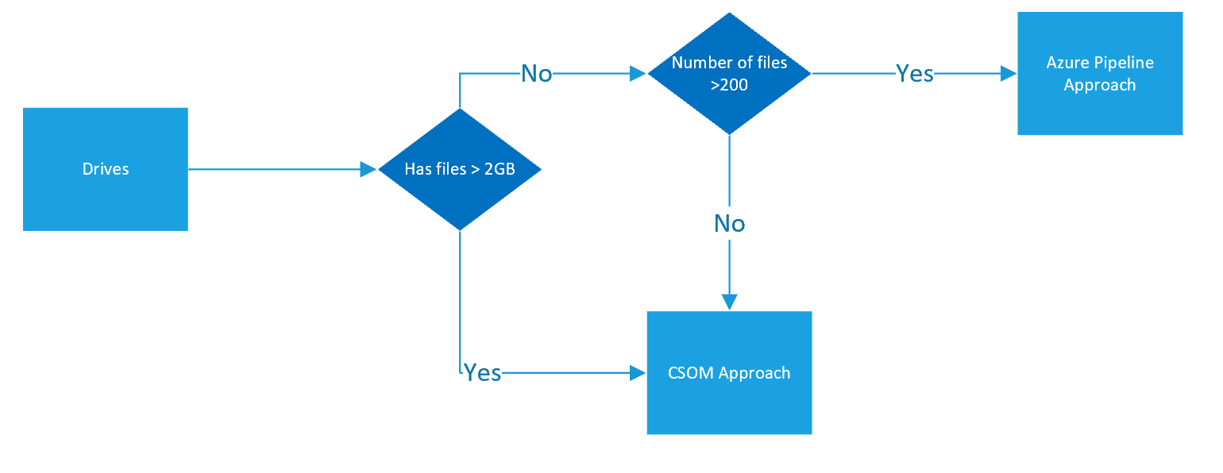

Issues
Issue Description | Resolution | Status
Access denied to Azure Pipeline Cloud Storage | Upgrade Metalogix Content Matrix File Share Version to 8.6.0.3 | Resolved

Limits of Sharegate
https://support-desktop.sharegate.com/hc/en-us/categories/115000076328-Limitations

Strength/weakness of Microsoft O365 migration tool

Best practices for improving SharePoint and OneDrive migration performance
This article explains the factors that influence performance when migrating content to SharePoint Online and OneDrive.
Migration performance can be impacted by network infrastructure, file size, migration time, and throttling. Understanding these will help you plan and maximize the efficiency of your migration.
Currently, Microsoft's SharePoint Migration Tool (SPMT) as well as several third party vendor tools utilize the SharePoint API for migration. It leverages Azure and uses channels for large content transfer. Regardless of which migration tool you use, these factors will apply. Follow the recommendations listed below for each phase of your migration process.

Before migration
Planning is the key to optimizing your migration. Determine what content you need to migrate, prioritize when the content needs to be migrated, and decide on what the optimal migration infrastructure should be.

I. Scan the source
The first rule of a good migration is to know your source; evaluate and triage your content before you migrate. What content really needs be migrated? What can be left behind? How many file versions should be included? The amount of content you migrate will determine the overall size of your project.

II. Package the content
This step is where the tool creates a proper package for the content to be imported into the cloud. This step is automated in SPMT and in most third-party tools.
Package size. To improve migration throughput, we recommend that you package at least 250 files per transfer. For the transfer size we recommend a minimum of 100MB and less than 250MB per package. This will result in a faster upload speed to Azure and leverages the scale capabilities of the migration API.
The following table provides estimates of the type of speed you may achieve based on the types of content you are migrating.
Type of metadata | Examples | Maximum
Light | ISO files, video files | 2 TB/day
Medium | List items, Office files (~1.5MB) | 1 TB/day
Heavy | List items with custom columns, small files (~50kb) | 250 GB /day
- Large file size migrates faster than smaller ones. Small file size can result in larger overhead and processing time which directly impacts the performance.
- Files migrate faster than objects and list items.
The speed of this step depends on the efficiency of the tool you are using and the type of content that you package. Splitting your packages in a smart way is something that will greatly improve this step. In addition, ensure that your permissions, sharing, or other limits are set up properly for migration and are within SharePoint Online limits and boundaries.

During migration

I. Upload to Azure
SPMT or your third-party tool will migrate your content into SharePoint Online using the Migration API, leveraging Azure as a temporary holding place.
If you have a good connection and can configure your datacenter, choose the same datacenter location closest geographically to you for your Azure and your Office 365 account. Migration data throughput is highest during off-peak hours, which are typically nights and weekends in your region's time zone. Your region's time zone is determined by where your SharePoint Online tenant is set up.

II. The Migration API
The final step of the migration process is when the data is moved from Azure to SharePoint Online. This action is transparent to the user when using SPMT or a third- party tool.
To improve throughput, users are encouraged to run parallel tasks against different site collections if possible. We recommend that you do not submit more than 5,000 migration jobs/requests at one time. Over-queuing the network will create an extra load on the database and slow migration down. Make sure your task has completed before you upload a new migration request. Some tools may already be doing this for you.
During migration, it is not uncommon for your migration task to be throttled. Throttling is implemented to ensure the best user experience and reliability of SharePoint Online. It is primarily used to load balance the database and can occur if you misconfigure migration settings, such as migrating all your content in a single task or attempting to migrate during peak hours.
For more technical background and information, please see
- Migration API Overview
- Avoid getting throttled or blocked in SharePoint Online

After migration
After the migration is completed, verify that your content has been successfully moved to SharePoint Online or OneDrive.

FAQ and Troubleshooting
Question: My migration is going so slow or I am being throttled. What can I do?
Answer: Check that you have configured your migration settings properly. Turn off any software that you do not need to use during migration. For example, disable any file synchronization program or antivirus program on the migrated content. This will help reduce throttle and improve performance.
Question: I continually getting throttled while I am attempting to migrate. Can Microsoft turn off the throttle to help me with migration?
Answer: Unfortunately, we are not able to disable throttle. Throttle is built into our server to protect the database from going down. If you are being throttled with a 429 error, it's an indication that your migration tool is overly aggressive and is over its allocated quota. Please try to migrate during off-peak hours or reduce the number of VMs you are using.
If after several days you are still experiencing excessive throttling, please open a Microsoft support ticket. Include the following in your support ticket:
- How often are you seeing the throttle (e.g. throttle count/hour)
- How much data were you being able to migrate (e.g., 2MB per hour or per day)
- The name of the third party app are you running
- The total size of the content you wish to migrate
- Your migration schedule
- Your Company name and Tenant URL
Question: How much can I migrate per day?
Answer: Plan to migrate at a maximum of 2TB/day.
Question: I have a very big migration (> 100 TB) and I would like some help, who should I contact?
Answer: For larger than a 100TB migration, please submit a support request with Microsoft indicating that you are doing a large migration (>100TB). Follow these steps:
- Click on Need help?
- For the title, enter "SharePoint Migration over 100TB".
- Include all of the following on the support ticket:
  - Your company name and Tenant URL
  - Estimated size of your migration
  - An estimate of when you would like to start and complete your migration
  - Describe where you are migrating your content from, such as SharePoint Server, Box, GDrive, File shares, etc.
Question: I have tried everything, but nothing works. Now what do I do?
Answer: Open a support ticket with http://support.microsoft.com.

Ref: https://docs.microsoft.com/en-us/sharepointmigration/sharepoint-online-and-onedrive-migration-speed

Metalogix Limitations:
Special character getting replaced
File/Folder Path Limitation | Total URL length cannot exceed 260 characters and file or folder names may not exceed 250 characters
These names aren't allowed for files or folders | _vti_bin, FORMS, folder name

Convertible Objects:
The following table describes the items will be converted via Metalogix tooling:

Sites | Lists | Items
Permissions and Sharing | Permissions and Sharing | Permissions and Sharing
Tile | Documents | Versions (5)xx
Logo | Items
Pages | Views
Web Parts | Content Types
Managed Metadata Terms | Managed Metadata Columns
Declarative Workflows | Declarative Workflows
OOB Themes
Site Columns
Navigation
Content Types
Property Bag
Quota

Non-Convertible Objects:

The following table describes the objects will not be converted the Metalogix tools and must be remediated by conversion team and site owner:

Sites | Lists | Items
Running workflows or history | Running workflows or history | SSRS reports
Custom user profiles or values | Custom list forms – add, edit, view | Draft version items are hidden with preceding _
Web Templates | List templates | Checked out / Locked with no previous checked in version
Hidden Lists | Hidden Lists
Checked Out Versions -  Pages | Checked Out Versions –  List-Library items
1st version checked out –  Pages | 1st version checked out –  List-Library items
Anonymous sites/pages | Recycle Bins (both)
Un-ghosted/Customized pages | Access Request List
Custom Apps/ 3rd party components, web parts | IRM Settings
Custom site branding, design packaging, definitions, themes
Information Management policies
Full trust code / Sandbox solutions
Custom events receivers
Custom Managed Paths
Alternate address mapping
Usage Reporting
Site Settings
Vanity URLs
Custom Web Parts

SharePoint Migration Tool Limitations:
Characters that aren't allowed | " * : < > ? / \ |
File/Folder Path Limitation | File or folder names may not exceed 400 characters
These names aren't allowed for files or folders | .lock, CON, PRN, AUX, NUL, COM1 - COM9, LPT1 - LPT9, _vti_, desktop.ini, any filename starting with ~$.

Also lessons you learned from your file share migration
- SPMT is 30 times faster than Metalogix CSOM
- Filter option is lesser in SPMT than Metalogix
- You can’t filter with file name or folder name
- Can’t configure distributed migration in SPMT
- Can configure schedule job

